Docker

Defination:

Docker is a software platform that allows you to build, test, and deploy applications quickly. Docker packages software into standardized units called containers that have everything the software needs to run including libraries, system tools, code, and runtime.

Docker Image:

A Docker image is a file used to execute code in a Docker container. Docker images act as a set of instructions to build a Docker container, like a template.

Docker Container:

A Docker container image is a lightweight, standalone, executable package of software that includes everything needed to run an application: code, runtime, system tools, system libraries and settings.

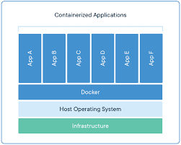

DockerFile:

A Dockerfile is a text document that contains all the commands a user could call on the command line to assemble an image. This page describes the commands you can use in a Dockerfile .

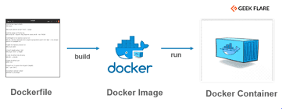

Docker Compose:

[Docker Compose](https://docs.docker.com/compose/) is a tool that was developed to help define and share multi-container applications. With Compose, we can create a YAML file to define the services and with a single command, can spin everything up or tear it all down.